
WORTHING FOOTBALL CLUB SUPPORTERS ASSOCIATION
Minutes for the Committee meeting held at The Tarring club on 27/05/2024 at 7.00pm

 | Item | Action | By  Whom | When
1. | Apologies for absence: Colin and James
2. | Attending Gary Cohen, Gordon Caplin, Ange Tanner, , Spencer Webb, Paul Garrard, John Loveland. Jacco Mulder, Nat Lunn
3. | Correspondence  Peter Vales resignation letter from WFCSA was discussed of which Gary has a copy. The committee discussed the contents and it was suggested that a thank you for all his work to be made via Socials/email alongside an acknowledgement of the feedback placed on various social media sites. Going forward Rebel Yell commentary will be taken in house by the Club Media team which has been agreed verbally. | Statement to be drafted. | Jacco | Statement to be agreed and sent out ASAP.
4. | Minutes of the previous Committee meeting | Confirmed at the meeting. | Gary
5. | Matters arising.  John has had a meeting with Keith which was positive. Keith and Barry wish to attend the next supporters association meeting. It was agreed they could attend the beginning of the meeting before other agenda items are discussed. | John to advise Keith and Barry of the date and time of next meeting and ask for a room to use at WFC – works permitting, otherwise alternative venue to be found. | John | 24.06.24
6. | Chairman's Report.  Gary continues to work on prices for transport for away matches using his contacts. | Ongoing.
7. | Treasurer's Report.  MK Windows have agreed to continue as sponsor to the Podcasts.  Gerry is still in the process of obtaining the bank account and ticketpass access (working with James re ticketpass)  Gerry is working with Gary on coach travel for next season. The club have stated that any coaches run by them will be for players and staff only, not fans.  Outgoings already approved – badges for next season, womens end of season awards.  Current bank account balance is around £8.5k |  | Gerry and Gary | 24.6.24
8. | Membership.  Colin sent his apologies.  Gerry confirmed that the badges had been ordered.  Membership is currently under discussion in a smaller working party. It was discussed that WFCSA membership recruitment may be more difficult due to the current building works. There will be no home friendlies and the first few games may be away fixtures. Therefore, committee need to look at other ways of signing members up to WFCSA ASAP. |  | All | 24/6/2024

9. | Fixture Posters.  More support needed to distribute in other areas of the town. | A list of people allocated to fixtures posters is attached to these minutes
10. | Sponsor A Goal & 50/50  Paul handed over a sum for the Sponsor a Goal. Agreed same format for next season. |  | Paul
11. | Player of the Month/Season and Milestone Awards.  It was discussed that Joel Colbran and Kane Wills have renewed their contracts so would likely be due further Milestone awards in the near future.  WFCSA to purchase A4 photo frames for these presentations. |  | Gordon  Gary
12. | Proposal by James, Spencer and Jacco to upgrade the Rebel Yell Podcast equipment.  This is to enable ease of broadcast with multiple guests and there is a plan for a live podcast pre season.  Spend agreed up to £650 – proposed by Jacco, seconded by Paul. All voted in favour. |  | James/Spencer/Jacco
13. | Decisions Made Under Point 9 of the Constitution/Financial Proposals.  It was noted by Ange that the Constitution does not have a Vice Chair.  Also Directors of the WFC cannot be members of the WFCSA.  The Constitution can be changed at the next AGM if the committee feel appropriate. |  | Ongoing committee discussion | AGM
14. | WFC Liasion  As already discussed in matters arising John has met with Keith and discussed issues such as priority tickets, the development of WFC’s 1886 club in the front bar area, travel arrangements, reserved seating and programmes.  Keith and Barry wish for better communication with the supporters. |  | Keith and Barry to be invited to part of the next WFCSA meeting next month and to request a venue from the club. Committee need to have questions for them. | John 24/06/2024
15. | AOB  Language in the club  It was discussed about the level of bad language used at home and away games, and there were signs up stating that WFC was a family club. The committee felt that this was down to the club to monitor and take action with the safety stewards in place at matches.  Mission Statement  It was proposed that to provide clarity of the WFCSA aims a mission statement be put in place. It was discussed that this needs to fit in with the objectives of the constitution which was adopted earlier this year at the AGM. 5 examples were provided which will be attached to these minutes for committee members to review. |  | This could be discussed with Barry and Keith at the next committee meeting to guage the club’s view.  Gerry | 24/06/2024  24/06/2024.
 | WFCSA Secretary  Thanks was given by the committee to Ange who is standing down from this role after 6 years hard work. Nat has offered to take on this role.  Proposed by Ange, Seconded by Gary. Majority vote. Ange will hand over admin of whats app groups and WFCSA inbox to Nat.  Next meeting 24/06/2024 7pm  Venue TBC | Contact the Women's Team and check they are happy to share their  evening (10th May)  Draft a message to WFCSA to invite them.  Email the Invitation to all members. | Ange  Ange  Ange  Colin | 24/06/2024  1.5.24  1.5.24  3.5.24
16. | Meeting finished: 8.15pm | Date of next meeting 27.5.24 at 7pm.

Appendix A. Issued raised by WFCSA with the Club.
Question/Issue | Date WFCSA  sent message | Progress | Status
No correspondence had been received from the Club regarding the release of shares, which was discussed last year (2023) confidentially with Barry Hunter and not minuted. Whether this action has been taken is unknown. | 27.6.23 | None | Open
Report put to the WFC Board proposing a "Fan Advisory Board" or equivalent rejected by the Board and delegated to Keith to take forward. | 29.6.23 | None | Open
An email was sent to Gary by Keith with a document that the WFCSA was being asked to sign. However, it appeared incomplete and Gary responded at the end of February, requesting the extra information. (See Appendix A.) No response has been received. | 22.2.24 | None | Open
A number of questions were raised at the AGM. | 11.2.24 | Chased on 16.3.24. A single "holding" email response on 18.3.24. See below. | Open
"...The first relates to how the WFCSA and WFC Ltd might communicate effectively going forward. The Recommendation agreed was "That the WFCSA works with Worthing Football Club Ltd. representatives to develop the agreed protocol for communication and provides feedback to the Membership on progress and outcomes."One of the members of the Committee has volunteered to lead on "Club Liaison" (John Loveland) and we have the WFCSA Hotmail account, for example, with the thought that a single point of contact (whether person or email, for example) for both organisations might be helpful? If you would share your views on an approach the would work well for you and your team, that would be great. | 16.3.24 | A single "holding" email response on  18.3.24  "I have spoken to Gary about the points raised at the recent Q&A with the Board at  the WFCSA AGM  and will be responding to him directly in an email  shortly. I will ensure my response includes the points you have detailed in your email, thank you. | Open
The second was a proposal by a WFCSA member (Robert Pepper) as follows: Object:  To encourage Worthing Football Club and  Supporters to consider joining the "Fair  Game" campaign. The Recommendation "That the WFCSA requests that WFC consider "https://www.fairgameuk.org/fair-gameclubs" and provides feedback to the  Membership on progress and outcomes" was accepted by majority vote at the meeting, so we would be seeking feedback from the WFC  Board on their views in joining that campaign. | 16.3.24 | A single "holding" email response on  18.3.24  See above | No answer.
The last is a request that nominated members of WFCSA , at the various end of season presentation events held by WFC be invited to | 16.3.24 | A notification of the event of less than a week's notice was | Completed.
attend and present the "Player of the Season Awards" (which are supplied by WFCSA.) |  | given, so a "draw" for the WFCSA member to do it was not possible. The presentation was made by Trevor Smart and Stephen Stapley as long standing members of the Association.  The Women's Event has been confirmed for 10th May and all WFCSA are invited to join in.
We also gather from Barry's email that you will be providing some updates on questions raised at the Q&A session, too?..." | 16.3.24 | A single "holding" email response on  18.3.24  See above | Open
Safety Issues Raised by Supporters
People are being allowed to stand in front of the South Stand, when it should be a walk way only (raised at the Q&A session). Feb 2024 | Feb 2024 | Shared with the Club on 6.5.24 | Open
There is no crush bar for the West stand: a supporter saw people push forward then fall down the steps into a "pile of bodies".  Fortunately, no one was badly hurt, but it's an accident waiting to happen. April 2024 | April 2024 | Shared with the Club on 6.5.24 | Open
Some of the segregation layout arrangements affect travel distance and access to lateral gangways, so the top step on the uncovered East Stand should be kept clear in these cases.  April 2024 | April 2024 | Shared with the Club on 6.5.24 | Open
Some of the segregation layout arrangements would make evacuation of the ground in 8 minutes practically very difficult, especially when the red tunnel is in use. April 2024 | April 2024 | Shared with the Club on 6.5.24 | Open
Some of the segregation layout arrangements and the TV gantries will decrease the capacity the ground. April 2024 | April 2024 | Shared with the Club on 6.5.24 | Open
Chatting to some of the regular stewards they say they have not done a fire/evacuation drill for the whole season. April 2024 | April 2024 | Shared with the Club on 6.5.24 | Open
Despite bag searches, flares/smoke bombs have got through - e.g. Lucas Covolan picked up the one thrown on the pitch at the Maidstone game and threw it to one side.  May 2024 | May 2024 | Shared with the Club on 6.5.24 | Open

Appendix B.
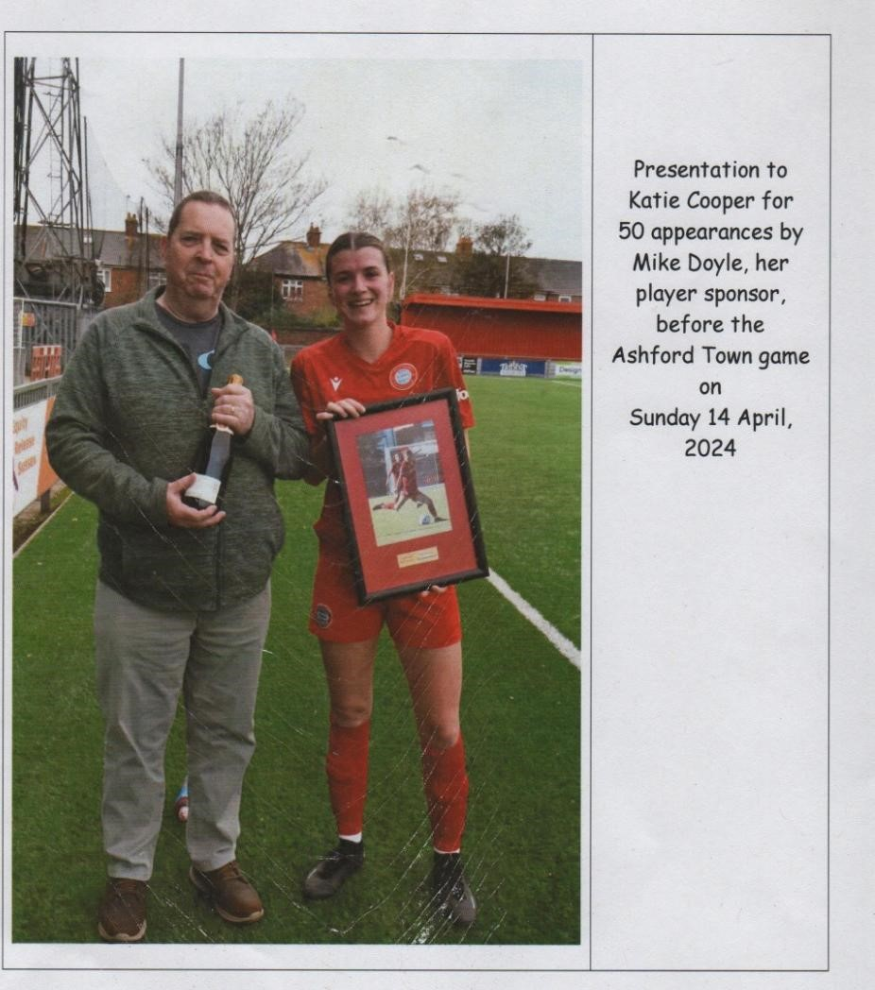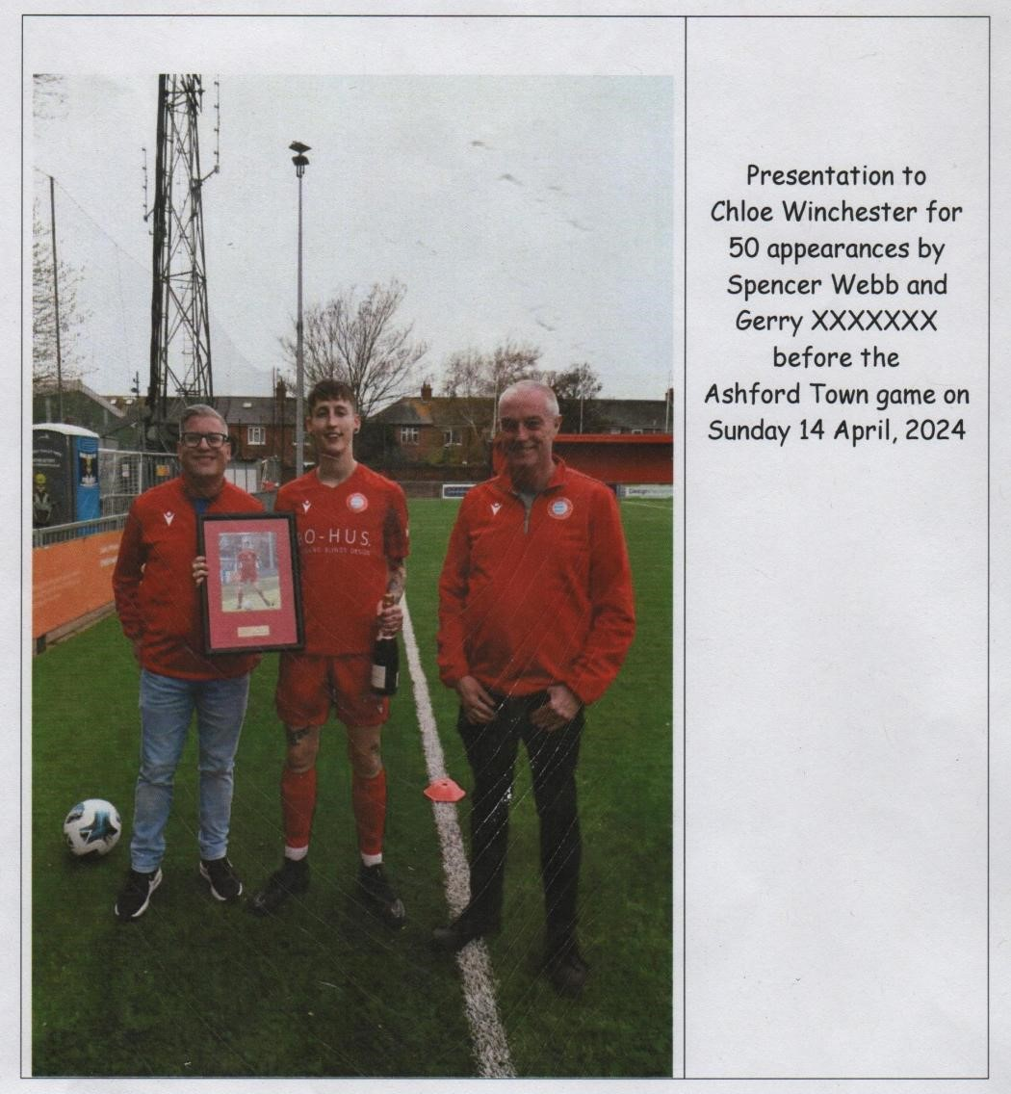

Gerry Donohoe

